

Email for comments: [asif.muzaffar@secp.gov.pk](mailto:asif.muzaffar@secp.gov.pk)

Last Date of Submission of Comments: April 24, 2025

Date of issue: March 25, 2025

*CONCEPT PAPER  
   
SAME DAY CORPORATE BANK ACCOUNT OPENING THROUGH eZfile*

Contents

Introduction 2

Enhancement 1: Extending the Utility of eZFile Portal for Companies Corporate Bank Account Opening 2

**Push Based Mechanism** 3

Benefits of Account Opening via eZFile Portal 5

Enhancement 2: Banks Role in Utilizing DFI to Register Companies 5

Way Forward 6

Annexure A 8

Annexure B 10

# Introduction

1. To facilitate companies seeking incorporation and to make the process digital, SECP launched its eZfile online portal. Companies can now submit their incorporation request online and provide the requisite information and documents. Recognizing the utility of the eZfile as a repository of companies’ verified statutory documents, SECP introduced a **Digital Financial Institution (DFI)** portal for banks and financial institutions which will allow them to access such documents for the purpose of corporate account opening. The portal also established connectivity with the FBR system to provide the critical function of registering company National Tax Number (NTN).

2. Since its launch, 49 banks and financial institutions have been using the portal for obtaining statutory documents of companies for account opening, signifying the important role it is playing in facilitating the companies and banks. The following diagram explains in pictorial form how the banks connect to the online portal and extract required information:

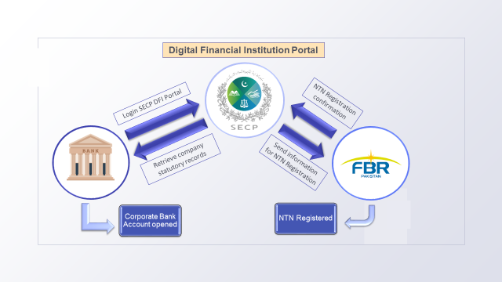

**Illustration 1: DFI connectivity with Banks and FBR system**

# Enhancement 1: Extending the Utility of eZFile Portal for Companies Corporate Bank Account Opening

3. The vision of the eZFile Portal can be further extended to provide a complete corporate bank account opening solution. In this respect it is recommended that the eZfile portal shall capture complete information and documents required by banks to open corporate account(s). To achieve this purpose, a separate section in the portal will be introduced where companies may select “Corporate Account Opening” option at the time of incorporation. The interface will require companies to enter additional information and documents in the portal other than the ones they had currently provided for registration purposes and which are necessary for corporate account opening purposes. A study based on a sample set of banks identified the most common documents and information required by banks to open a corporate account **(refer Annexure A)**. This compilation will serve as a guide on the additional information and documents that can be required from the companies to enter in the eZFile portal for account opening process at the time of incorporation.

4. Upon incorporation of a company, the information and documents entered/attached in the portal become part of the SECP records as per the current practice adopted for documents obtained for company incorporation. Upon incorporation of company, the relevant information and documents so collected shall be transmitted to the bank(s) selected by the applicant for the purpose of corporate bank account opening. This development will allow banks access to complete and verified information and documents from a single source and make the corporate account opening process straight through for companies. The information and documents stored on the eZFile portal will be acceptable for all banks.

5. In this context, the following push based mechanism can be implemented to facilitate seamless interaction between the eZFile portal and banks for the exchange of information required for corporate account opening:

## **Push Based Mechanism**

* 1. The eZFile portal will function as a conduit to facilitate account opening (similar to process established for RDA and Shared KYC but this time for banks). This means that a company will be able to initiate account opening request from a separate interface developed in the eZFile portal. As a pre-requisite, all the banks will be connected to the eZFile Portal via API.
  2. In the account opening interface in eZFile, company will be shown all the banks connected with the Portal.
  3. Company will select their desired bank and authorize the portal to forward their information and documents to the selected bank.
  4. eZFile portal will transmit the company information and documents to the bank via API.
  5. Bank will be notified of account opening request initiated by the company from eZFile portal and process the request according to its procedures.
  6. On successful account opening, bank will notify the eZFile portal and company of the account details.
  7. Company will be able to check the status of its account opening request on the portal as well as through appropriate notifications from the portal.
  8. Company will be able to initiate account opening request with multiple banks using the same information and documents stored on the eZFile portal.

6. In view of the above, to streamline corporate account opening, a standardized application interface to be developed in collaboration with the State Bank of Pakistan (SBP), Pakistan Banking Association (PBA) and banks, integrating it within the eZFile incorporation module. This should include a standardized system-generated board resolution for account opening (Annexure-B) and API integration with all banks to facilitate seamless transmission of company data. Banks should be able to auto-open accounts based on verified information received from SECP via eZFile, ensuring same-day processing. Additionally, a centralized KYC function should be established to eliminate redundant submissions across different branches. Upon successful account opening, companies should receive e-alerts for confirmation. Further, considerations must be made regarding the minimum deposit requirement and the biometric verification process for authorized signatories to ensure compliance and operational feasibility.

7. An alternative approach could involve exploring the feasibility of provisional account openings with banks, enabling businesses to commence operations with restricted access to transactions or services while verification is underway. In case of discrepancies, banks should have the authority to suspend or deactivate the account. This system would allow for swift account setup with limited transaction capabilities until all compliance requirements are fulfilled. Typically, such provisional accounts would have lower transaction limits or restricted service access until the verification process is complete. Moreover, for the purpose of auto-opening of corporate account, the **RAAST platform** which is generally connected with all banks, may also be leveraged for **integration purposes, if deemed appropriate,** to facilitate smoother **and standardized transaction processing across all banks to streamline corporate account openings**

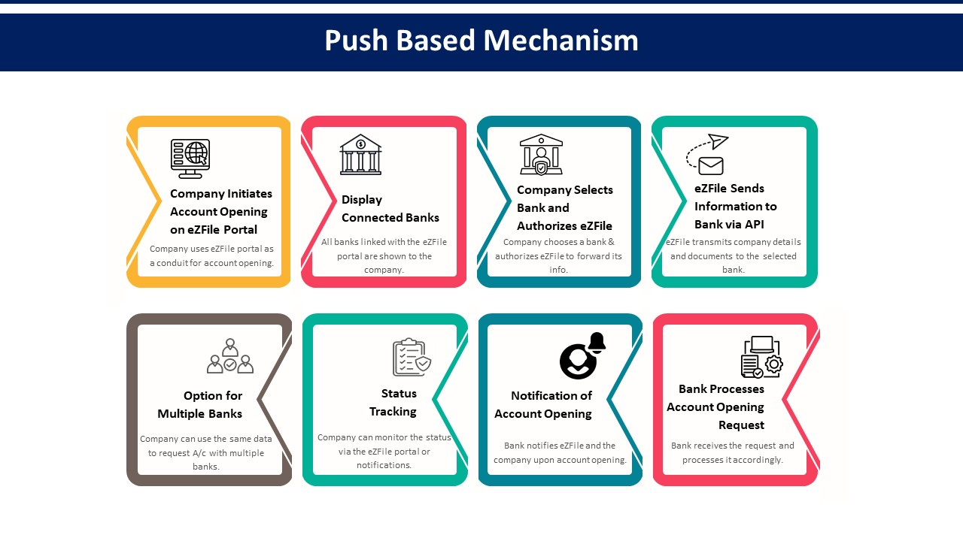

**Illustration 2: Push Based Mechanism Process Flow**

8. The mechanism presented above shall facilitate companies to open account with banks using the verified information already available in SECP records.

# Benefits of Account Opening via eZFile Portal

* Corporate Account opening process will be completely digitalized with minimal human intervention.
* Data gathering and KYC leg of corporate account opening will be greatly simplified for the companies and the banks by having access to verified information and documents from SECP records. This will result in increased efficiency and accelerate account opening timelines.
* Sharing information through APIs will result in real time extraction of required information from the portal, speeding up the process of data gathering.
* Company will only have to enter information and documents one time and can use the same to send account opening requests to multiple banks.
* Reduces manual documentation, making account opening faster and more efficient.
* Banks receive pre-verified company data from SECP, reducing verification delays.
* Companies can initiate multiple requests without re-submitting documents.

# Enhancement 2: Banks Role in Utilizing DFI to Register Companies

9. The objective of DFI portal to speed up corporate account opening process by exposing the information stored in eZFile to the Banks. However, there is a need to look beyond this scope and explore further utilization of this facility. It is proposed through this portal banks can play a more pro-active role in promoting the incorporation of un-registered companies. Many of the banks corporate account holders are un-registered and either lack the awareness or the knowledge to get registered with SECP. In such case the banks are ideally placed to facilitate their corporate clients by acting as the intermediary where they will provide the requisite details of incorporation to SECP on behalf of the company through this portal. Furthermore, banks already have most of the information and documents required for registration available to them and have the necessary established communication channels to obtain any missing information from the client directly. This information exchange between bank system and portal can be facilitated either through API connectivity or through a special interface developed on the portal itself accessible to the banks.

10. The goal of registering all the unregistered companies will be greatly speeded up as banks cater to a vast portfolio of corporate clients. The following diagram provides an illustrative view of the process:

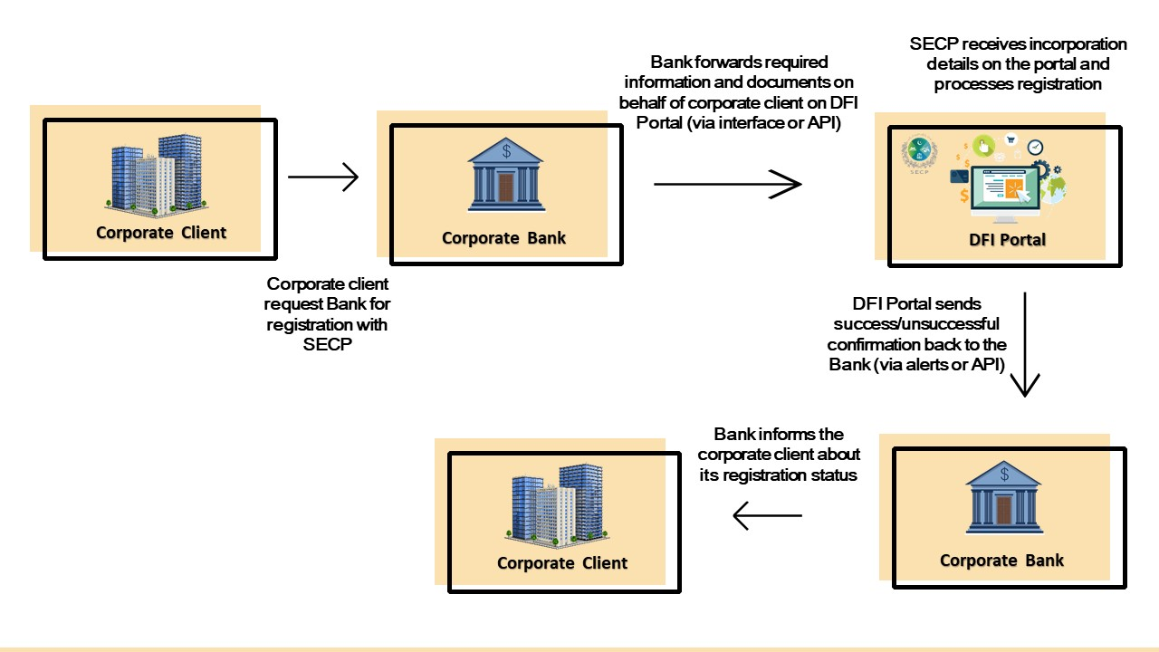

**Illustration 4: Registration via DFI Portal Process Flow**

# Way Forward

11. A Working Group will be formed comprising of senior representatives from SECP, Pakistan Banking Association and SBP to deliberate on the enhancements presented above and to finalize the regulatory and operational framework. The implementation roadmap includes:

1. Identifying corporate account opening mechanism.
2. Developing an API prototype for bank integration.
3. Pilot testing with a selected group of banks.
4. Gradual rollout based on bank readiness and adoption levels.
5. Monitoring and compliance tracking to assess system efficiency.

The enhancements aim to provide even greater facilitation in opening corporate accounts by reducing the time taken in data gathering and performing KYC, enabling real time access to information in standardized form and extend the companies’ access to multiple banks from a single platform. Furthermore, with an added feature it can leverage the banking network reach and expertise to increase the registration of companies with the SECP. The proposed enhancements to eZFile aim to provide a fast, standardized, and secure corporate account opening solution. By reducing documentation burdens, leveraging API-based automation, and integrating banks into the company registration process, SECP can significantly improve Pakistan’s business climate and financial inclusion. Collaboration with SBP and the banking sector is essential to ensure successful implementation and nationwide adoption.

# Annexure A

We conducted a study from a sample of banks to determine the most common documents and information that are required for corporate account opening in different category types of companies. The banks included in the sample are **Meezan Bank, UBL, MCB, Bank Al-Habib and Faysal Bank.** The summary is presented below:

|  |  |
| --- | --- |
| **Company Type** | **Documentary Requirements** |
| **Limited Companies/Corporations** | * Certified copy of Resolution of Board of Directors for opening of account specifying the person(s) authorized to open and operate the account; * Certified copy of Memorandum & Articles of Association; * Certified copy of Certificate of Incorporation; * Certificate of Commencement of Business (wherever applicable); * Attested copies of valid identity documents of all directors and person(s) authorized to open and operate the account; * List of Directors on Form 29 certified by SECP (wherever applicable); * List of Directors on Form-A/Form-B issued under Companies Ordinance 1984, as applicable; * Attested copies of valid identity documents of individual (natural person) shareholder, holding 20% or above (10% or above in case of EDD) stake in company. For legal persons holding share equals 20% or above, photocopies of identity documents of their individual shareholders holding 20% or more. * Signature Card |

|  |
| --- |
| **Information Requirements** |
| * Company business name/Title of Account * Company Category/Type of Entity:   + Private Limited   + Public Limited   + Public Unlisted   + Financial Institution   + Other (specify) * Nature of business:   + Services   + Manufacturing   + Agriculture   + Retail   + Financial   + Import/Export   + Others (specify) * Business Incorporation Date * National Tax No. (NTN) * Sales Tax Reg. No. (STRN) * Business Reg. No. (BRN) * Official/Mailing Address:   + Complete Address   + City   + Province   + Telephone No   + Fax No.   + Postal Code * Registered Address (if different from above):   + Complete Address   + City   + Province   + Telephone No.   + Fax No.   + Postal Code * Resident or Non Resident status * Currency of Account   + PKR   + USD   + GBP   + Euro   + Others (specify) * Type of Account:   + Current   + Savings   + Business   + Foreign Currency   + Other (specify) * Authorized Signatories   + Salutation   + CNIC No.   + Expiry Date   + Official Position/Designation * Details of Bank Accounts with Same/Other Banks * FATCA/CRS (if applicable) * Zakat Exemption * Operating Instructions * Declarations & Undertakings * Terms & Conditions |

# Annexure B

**BOARD RESOLUTION**

**RESOLUTION FOR OPENING OF BANK ACCOUNT**

M/s. **[Name of Company]** (hereinafter referred to as the “Company”) was incorporated with SECP on **[Date of incorporation]** with following subscribers as directors.

|  |  |  |
| --- | --- | --- |
| **Sr. No** | **Name of Directors** | **CNIC No.** |
| **1** | xxx |  |
| **2** | xxx |  |

**Resolved** **that** the following Directors/Officers of the company are hereby authorized to open and operate the Bank Account(s) and to complete all the formalities in relation to opening of Bank Account(s). Moreover, Bank(s) be and is hereby informed and authorized to honour instruction(s) for payments drawn, accepted, made duly signed on behalf of the company by the following authorized persons.

|  |  |  |  |  |
| --- | --- | --- | --- | --- |
| **Sr. No** | **Name of Signatories** | **Designation** | **Authority Type** | **CNIC** |
| **1** | xxxx |  | Singly/Jointly | xxxxxxxx |
| **2** | xxx |  | Singly/Jointly | xxxxxxxxx |

**Further resolved that** the resolution will remain in force until it is superseded or is revoked through subsequent resolution passed by the company.

**Resolution Passed by:**

|  |  |  |  |
| --- | --- | --- | --- |
| **Sr. No** | **Name of Director(s)** | **CNIC** | **Signatures** |
| **1** | xxx |  | Electronically Signed |
| **2** | xxx |  | Electronically Signed |

Date: - **[Date of incorporation]**

**Disclaimer: -** Please note that the aforementioned resolution is applicable/valid only at the time of incorporation to facilitate swift opening of Bank accounts. The company shall directly provide fresh resolutions to the Banks in case it intends to change the above signatories in future. The company is not required to file/communicate fresh resolution(s) to Banks through the Bank Portal.