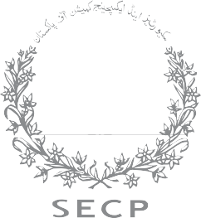

CONSULTATION PAPER

COST AUDIT REGIME IN PAKISTAN

The cost audit regime plays a vital role in enhancing transparency, efficiency, and accountability within the corporate sector. By analyzing cost records, cost audits provide valuable insights into operational efficiency, pricing strategies, and resource utilization. This consultation paper aims to evaluate the current cost audit regime in Pakistan, identify challenges, and propose measures to strengthen its effectiveness. Stakeholders are invited to share their feedback and recommendations to refine the regulatory framework.



1. EXISTING REGULATORY FRAMEWORK OF COST AUDIT

* 1. The emergence of cost accounts and cost audit has evolved gradually in Pakistan. Section 230 of the Companies Ordinance, 1984, required companies (engaged in production, processing etc.) to maintain books and accounts with respect items of cost, as may be prescribed by the Commission. Such items were prescribed and notified through special orders of the Commission starting from 1990.
  2. The requirement of audit of cost accounts was not prescribed until 1998, when the Cost Audit Rules were notified. At the time of introduction of these requirements, only two special orders were in place applicable on Ghee & Oi and Cement. Another special order applicable on Sugar sector companies was passed in 2001.
  3. Subsequently, a general order of the Commission of 2008, was passed which enhanced the scope of cost accounts/audit regime to a total eight sectors (five new sectors). The general order did not take effect as it was initially deferred and subsequently withdrawn in 2011.
  4. Cost audit regime in Pakistan is summarized in following graph:

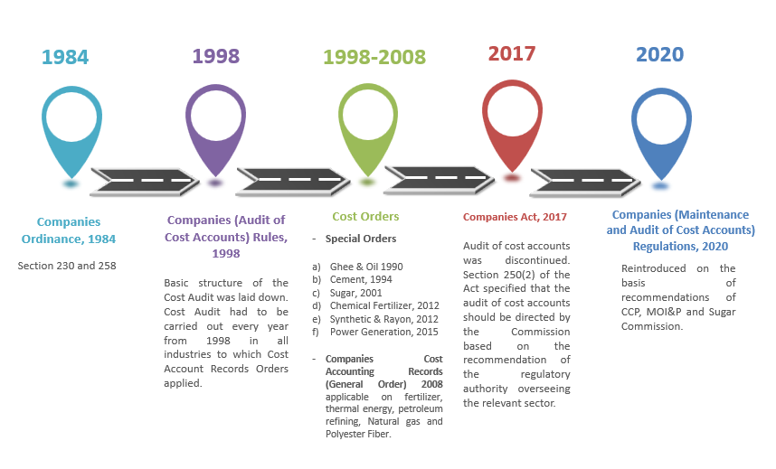

* 1. After promulgation of the Companies Act, 2017 (the "Act"), the requirement of cost audit was linked to recommendation of regulatory authority supervising the business of relevant sector. In 2020, CCP vide its policy note dated May 8, 2020, duly endorsed by Ministry of Industries & Production, recommended the reinstatement of cost audit for five sectors (at the minimum) namely; cement, sugar, vegetable ghee/cooking oil, fertilizer & wheat/flour. Moreover, Sugar Commission also recommended audit of cost accounts of sugar companies.
  2. Considering the above, the Commission notified (Maintenance and Audit of Cost Audit) Regulations, 2020 (“Cost Audit Regulations”) on December 14, 2020 which are currently applicable on aforementioned five sectors.



2. International Practice:

2.1 Currently, there is no publicly available evidence indicating that cost accounts are audited globally, with the exception of three countries: Pakistan, India, and Bangladesh. Below is a brief overview of other two jurisdictions:

1. **India:**

Concept of cost accounting was first introduced in the defense undertakings in 1920. Audit of cost accounts can be traced back as early as 1925 when a large number of firms were given contracts by then Government on cost plus basis and the Government started verifying the cost structure of such firms. Section 209(1)(d) and Section 233b of the Companies Act, 1956 became the backbone of cost accounting and cost audit in Indian corporate sector. Later, Companies (Cost Records and Audit) Rules, 2014 read with Section 148 of the Companies Act, 2013, came into force with effect from June 30, 2014. Aforesaid Rules cover a total of 39 sectors including telecommunications, generation/distribution of electricity, petroleum products, fertilizer, sugar, edible oil, cement etc.

**b. Bangladesh:**

Section 220 of the Company Act, 1994 contains provisions under which the government of Bangladesh may, by order, direct an audit of cost accounts be conducted by a Cost and Management Accountant. Cost auditing function is administrated and facilitated by Cost Audit (Report) Rules, 1997. Cost Audit is mandatory in sectors namely sugar, fertilizer, textile, fuel, pharmaceutical & jute.



3. Usage of cost audit reports in Pakistan:

**3. 1 Number of companies subject to cost audit:**

Following is the sector-wise distribution of companies:

|  |  |  |
| --- | --- | --- |
| **Sector** | **Listed Companies** | **Unlisted Companies** |
| Sugar & Allied | 27 | 44 |
| Cement | 17 | - |
| Fertilizer | 5 | 2 |
| Edible Oil & Ghee | 2 | 123 |
| Wheat & Flour | 0 | 54 |
| Total | **51** | **223** |

**3.2 Qualification of Cost Auditors:**

|  |  |  |
| --- | --- | --- |
|  | **Listed Companies** | **Unlisted Companies** |
| Audited by member of ICAP | 50 | 112 |
| Audited by members of ICMAP | 0 | 25 |

* 1. **Comparison of contents of Financial Statements Vs Cost Reports**

|  |  |  |
| --- | --- | --- |
| Content | Financial Statements | Cost Audit Reports |
| Balance Sheet | Assets, liabilities, equity | Not included |
| Income Statement | Revenue, expenses, profit | Not included |
| Cash Flow Statement | Operating, investing, and financing activities | Not included |
| Equity Statement | Equity movements | Not included |
| Notes | Accounting policies, detailed breakdowns, contingencies | Not included |
| Cost Statements | Not included | Cost statements for intermediary product, main product, packing, power, steam and demineralized water |
| Breakdown of Costs | Not included | 1. Quantities and value of input materials for each product 2. Quantities and value of utilities consumed. 3. Direct labour cost per unit of output. 4. Other allocated costs per product. |
| Variance Analysis | Not included | Explanation for significant variance |
| Reconciliation | Not included | Reconciliation of cost and financial accounts |

* 1. **Actions initiated under Cost Audit Regulations:**

Under the existing practices, enforcement actions pertain to non-appointment of cost auditor and late submission of cost audit reports. The following table provides an overview of actions taken since the promulgation of the Cost Audit Regulations:

|  |  |  |
| --- | --- | --- |
|  | **Actions against companies for non-appointment of cost auditor** | **Actions against cost auditor for late submission of cost audit reports** |
| **Listed Companies** | 15 | 5 |
| **Unlisted Companies** | 304 | 45 |
| **Total** | 319 | 50 |

* 1. **Availability of cost audit report to public:**

Cost audit reports contain detailed information on production costs and overheads, helping to identify inefficiencies, reduce wastage, and highlight areas for cost reduction, thereby improving operational efficiency. Currently, the Commission is only ensuring the appointment of cost auditors and the submission of cost audit reports.  While this vital information is submitted solely to the Commission, Registrar and board of directors, it is also valuable for ministries in determining prices for inputs such as sugarcane and feed gas.

Cost audit reports are currently not available for public. The Commission in General Order included the requirement of cost audit reports to be disseminated to the shareholders of the Company by uploading the same on Company’s website. However, CCP in its policy note dated August 30, 2011 raised their concerns over the public availability of the report and stated that it is against the spirit of the Competition Act, 2010. CCP further contended that cost audit reports contain commercially sensitive information and should only be available to management and the Regulator. Consequently, public dissemination of cost audit report was discontinued in Cost Audit Regulations of 2020. However, certified true copy of cost audit report can still be acquired from the Registrar Office after payment of a nominal fee as there are no specific regulatory requirements for the cost audit report to be kept as confidential.

In this context, the legal framework available in India and Bangladesh contains no such provision for making the cost audit report public. There was a provision in Indian Companies Act, 1956 (subsection 10 of Section 233b) which stated that the Central Government can direct a company to make available the report in full or in part to shareholders but this power was never apparently exercised by the Government.

As per the current regulatory framework in India and Bangladesh, the Cost Auditor is required to submit the report to the Central Government/Concerned Ministry and copy of thereof is shared with the Company.

Hence, availability of cost audit reports to the public has been a contentious issue due to competing interests between transparency and confidentiality. Cost Audit Report is treated as confidential document as it contains vital information which if divulged would affect competitiveness of trade and business of the Company.

* 1. **Cost Accounting Standards:**

Although the Institute of Cost and Management Accountants of Pakistan (ICMAP) has drafted cost accounting standards, there remains a pressing need to standardize and notify the cost accounting framework to enhance its effectiveness. This standardization may be achieved through collaborative efforts between the Institute of Chartered Accountants of Pakistan (ICAP) and ICMAP. Previously, a joint committee was formed by ICAP and ICMAP to address this issue, but no definitive conclusion was reached. A renewed and focused partnership between these bodies, with clear objectives and actionable outcomes, is essential to establish a cohesive and comprehensive cost accounting framework that caters to the evolving needs of businesses and regulators in Pakistan.

* 1. **Integration of the financial statement and cost audit reports:**

The integration of financial and cost accounting systems is crucial for ensuring that the notes to the financial statements can be seamlessly compared and reconciled with those of the cost audit report. Such integration fosters consistency, transparency, and accuracy across financial and cost reporting, enabling stakeholders to gain a comprehensive understanding of an organization’s financial health and cost efficiency. By aligning definitions, classifications, and reporting frameworks, discrepancies can be minimized, and the reliability of both financial and cost data is enhanced. Implementing standardized systems and digital tools for this integration not only simplifies reconciliation but also facilitates compliance with regulatory requirements and supports informed decision-making for management and external stakeholders.



4. PROPOSED WAY FORWARD:

Keeping in view above, SECP is of the view that above factors are necessitating a review of the current framework to balance transparency, regulatory oversight, and competitive fairness. Hence, stakeholders’ feedback is requested on following questions:

1. How do you perceive the current scope of cost audits under the existing framework in Pakistan?
2. Are there any particular industries or sectors where the cost audit framework should be expanded or restricted? If so, which ones and why?
3. What challenges do companies face with the applicability of cost audit regulations, and how can these challenges be addressed?
4. Should Cost Audit reports be integrated with annual audited financial statements in place of separate cost audit reports?
5. What does regulatory authority supervising the business means in terms of Section 250(2) of the Act. Moreover, can relevant ministries be considered authority supervising the business?
6. To enhance effectiveness and utility of cost audit reports, whether these reports be shared with relevant ministry and CCP for increased regulatory oversight and cost audit regulation may be amended accordingly?
7. What is your opinion on the sharing of cost audit reports with external stakeholders, including regulators and the public? Should they be fully/partially disclosed or kept confidential?
8. Whether cost accounting standards developed by ICMAP should be notified by the SECP to provide standardized framework to make it more effective?
9. How can the cost audit framework be adapted to better reflect the evolving business landscape (e.g., technological advancements, digitalization, etc.)?
10. Any other improvements do you think should be made to the overall cost audit framework to ensure it meets its intended objectives?



5. STAKEHOLDERS FEEDBACK:

Input and response may be sent via email to the SECP at fozia.perveen[@secp.gov.pk](mailto:regulatory.framework@secp.gov.pk) within 30 days of date of publication of this concept paper as per below format:

|  |  |  |  |
| --- | --- | --- | --- |
| **Name** | | | |
| **Name of the Regulated Entity (if applicable)** | | | |
| **Sr. No** | **Questions** | **Feedback on questions** | **Rationale** |
| 1 | How do you perceive the current scope of cost audits under the existing framework in Pakistan? |  |  |
| 2 | Are there any particular industries or sectors where the cost audit framework should be expanded or restricted? If so, which ones and why? |  |  |
| 3 | What challenges do companies face with the applicability of cost audit regulations, and how can these challenges be addressed? |  |  |
| 4 | Should Cost Audit reports be integrated with annual audited financial statements in place of separate cost audit reports? |  |  |
| 5 | What does regulatory authority supervising the business means in terms of Section 250(2) of the Act. Moreover, can relevant ministries be considered authority supervising the business? |  |  |
| 6 | To enhance effectiveness and utility of cost audit reports, whether these reports be shared with relevant ministry and CCP for increased regulatory oversight and cost audit regulation may be amended accordingly? |  |  |
| 7 | What is your opinion on the sharing of cost audit reports with external stakeholders, including regulators and the public? Should they be fully/partially disclosed or kept confidential? |  |  |
| 8 | Whether cost accounting standards developed by ICMAP should be notified by the SECP to provide standardized framework to make it more effective? |  |  |
| 9 | How can the cost audit framework be adapted to better reflect the evolving business landscape (e.g., technological advancements, digitalization, etc.)? |  |  |
| 10 | Any other improvements do you think should be made to the overall cost audit framework to ensure it meets its intended objectives? |  |  |
| **Confidentiality** |  |  |  |
| If you wish to keep all or any part of your submissions and your identity confidential, please indicate the same.  In all other cases, your provided comments can be made public, except your contact information. | | | |

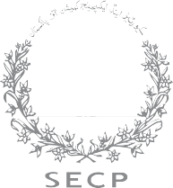

NIC Building, Jinnah Avenue, Blue Area, Islamabad. [www.secp.gov.pk](http://www.secp.gov.pk/)